**SO3AS**Smart catalytic-based system for abatement of polluting ozone at room temperature

## **PRINCIPAL ACADEMIC TUTOR**

## **Fabio Alessandro Deorsola**,

## Applied Science and Technology Department, Politecnico di Torino

## **ACADEMIC TUTORS**

## **Debora Fino**, DISAT Department,

## Politecnico di Torino

## **Lidia Castoldi**, Energy Department, Politecnico di Milano

**EXTERNAL INSTITUTION**

## Grinp S.r.l.

## **EXTERNAL TUTOR**

## **Francesco Parisi**, Grinp S.r.l.

**TEAM MEMBERS**

**Executive summary**

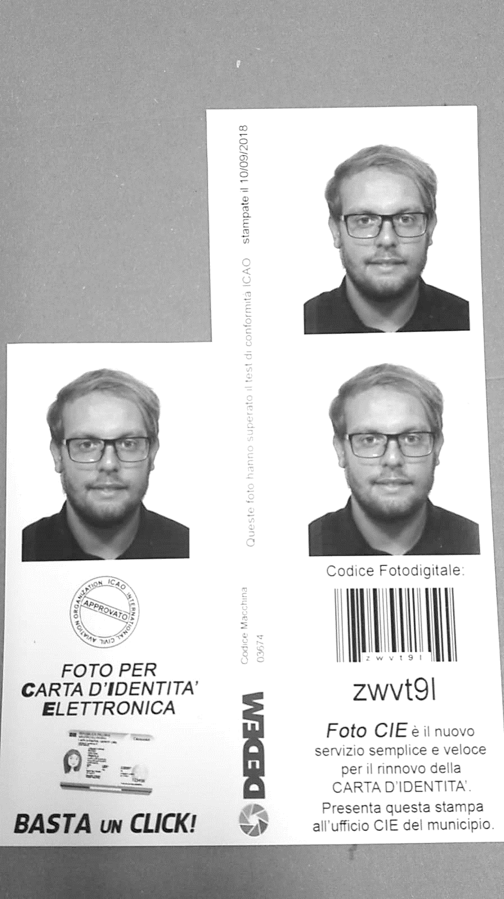Ground-level ozone badly affects human health, causing both respiratory diseases due to short-term exposure to ozone peaks and lung diseases of even cancer due to long-term exposure. The SO3AS project aims at reducing indoor ozone concentration to non-harmful levels especially in polluted cities and industrial environments subject to ozone slips. The solution found by the Team is a reactor packed with catalyst for the transformation of ozone to oxygen with high efficiency at room temperature, and be integrated with heating, ventilation, and air conditioning systems (HVAC) in buildings. The ozone abatement system designed deals with low ozone concentrations, and the target outlet concentration was selected according to the regulation standards. The selected catalyst is Carulite®, which converts ozone efficiently at a reasonable price. For the reactor design, the team performed accurate computational fluid dynamics (CFD) simulations in MATLAB. To assess the market viability of the solution, the Team performed a market analysis to find an appropriate customer sector, and northern Italy emerged as viable target.  
Finally, to investigate the interest of these customer in buying our ozone abatement device, a questionnaire was proposed to almost 600 people. This also tested the awareness and responsiveness to an informative campaign about the ozone problem. Finally, the integration of the device in HVAC systems was studied. An overall feasibility analysis was conducted merging the results of simulations and market analysis, finally converging to the needs of GRINP S.r.l., together with other companies and institutions facing indoor ozone pollution problems.

## **Luna Pratali Maffei**,

## Chemical Engineering,

## Politecnico di Milano

**Key Words**

smog; ozone abatement; catalytic device; simulations; cost minimization

## **Francesco Cannizzaro**,

## Chemical Engineering,

## Politecnico di Milano

 **D:\Poli_Mi\Alta-Scuola-Politecnica\09_FinalExam\SO3AS_Poster\SO3AS_image.emf**9

## **Lucrezia Maini**,

## Nanotechnologies for

## ICT, Politecnico di Torino

## **Rawad Ibrahim**,

## Petroleum Engineering,

## Politecnico di Torino

## **Andrea Giuseppe Landella**,

## Chemical Engineering,

## Politecnico di Milano

## **Federico Allocco**,

## Chemical Engineering,

## Politecnico di Milano

One of the principal tasks of the project: study, sizing and optimization of the catalytic system for the ozone conversion reactor (device).



In collaboration with GRINP S.r.l., the SO3AS project aims to study a dedicated catalyst-based system for the reduction to oxygen of ozone with high efficiency at room temperature. The possible end user of this system could be industrial activities but also public municipal entities. Indeed, this system will be a possible solution of the pollution in urban landscape. So, it requires a strong multidisciplinary approach, joining physics and chemistry, as well as chemical engineering, process design and management, environmental awareness and regulations’ knowledge.   
GRINP S.r.l. is an innovation-driven and knowledge-based Italian Innovative SME, devoted to development, implementation and industrialization of atmospheric plasma technology for different application such as textile products, film treatment and air treatments. Efforts directed under this vision have led it to require the design and realization of a new catalyst-based system: an air pollution control device able to abate ozone with high efficiency and treatment flexibility, overcoming major issues of current technologies about investment and operating costs*.* As described, the success of this ambitious project will lie on the strict synergy among the different skills and expertise composing the team, coupling technology, science, process management and sustainability. SO3AS will offer to the students the opportunity to learn all about the operation of the system and to explore different aspects of a technological devices driven towards sustainability and environment protection, under the leadership of a very dynamic and innovation-devoted SME aiming at expanding its position in the market. The management of the project, under the coordination the academic tutors, will see several progress meetings (one each 2 months), periodic visit to the Grinp site and dissemination actions through social media.

**Project description written by the Principal Academic Tutor**

Within the SO3AS project, the work to be undertaken might include:

• A literature study about the possible catalysts to be employed in the system, during which the final choice will be driven by availability, cost, handling and environmental-friendship.

• A fluid-dynamic modelling of the catalyst system, emphasizing the distribution of the gaseous feed for the optimization of the reaction.

• A re-think and redesign of the whole system to make it user friendly, safe and homologated (ergonomics, fool-proofing and standardization).

• A study of the possible fields and application scales, considering the company and user’s needs, the technical/technological and economic limits.

• A marketing study about the penetration of this system in the market of environment protection, with particular focus on a patent survey and on the actual and future regulation actions.

**Team description by skill**

*Luna Pratali*: as the team controller, coordinated the actions and planning of the group, and with her Chemical Engineering knowledge performed the first design concept and simulations for the device. Moreover, she completed the selection of the most feasible solution and collaborated to the final technical analysis.

*Francesco Cannizzaro*: performed the initial analysis on the ozone problem and air quality, with emphasis on the effects on health. He also organized the sensiti-zation campaign with the mean of a custom questionnaire, with the subsequent results analysis. Moreover, he performed the device manufacturing cost analysis.

*Federico Allocco*: devised the stakeholder analysis, with the user’s requirements and the global industrial/municipality choice analysis. He also completed the full market and financial analysis and evaluation, listing the ozone problem in parts of the world and evaluating the possibilities for the final market choice. Together with Lucrezia and Andrea, he helped with the smart sensor integration.

*Andrea Giuseppe Landella*: did perform the analysis and dimensioning of HVAC systems, and helped Luna with simulation codes. With his Chemical Engineering knowledge, he also helped with the final reactor (single/modular type) choice and devised the design of experiments for kinetic validation.

*Rawad Ibrahim*: performed the requirements and constraint analysis for the device, coupled with the catalyst choice and performed the existing solutions’ analysis, which helped define the final application of our solution.

*Lucrezia Maini*: with her Nanotechnology knowledge, she performed the analysis of the ozone detection sensor, by means of the material, interface and connection to the device in order to make it integrated with the control loop (smart).

The SO3AS project aims at reducing indoor ozone concentration to non-harmful levels, especially in polluted cities, industrial environments and offices subject to ozone slips. In collaboration with GRINP S.r.l., the project objective is to study a dedicated catalyst-based system for the reduction to oxygen of ozone with high efficiency at room temperature. The possible end user of this system could be industrial activities but also public municipal entities. Indeed, this system will be a possible solution of the pollution in urban landscape. The main goal of the project is the completion of the innovative system and the development of the business proposal up to commercialization stage.

**Goal**

Ozone is found in gas phase as a natural component of the upper stratosphere between about 10 km and 50 km above the Earth’s surface. Stratospheric ozone is produced naturally from short-wave ultraviolet rays between 240 nm and 160 nm. The stratospheric ozone layer filters out sunlight wavelengths from about 200 nm to 315 nm. This filtering activity is very useful for life on planet Earth. In fact, ozone absorbs the UV-C and the entire UV-B bands, which are responsible of sunburns in humans and direct DNA damage in living tissues in both animals and plants. Unlike stratospheric ozone, ground-level ozone is both man-made and created by natural emissions, and it is currently considered a pollutant as it is one of the main components of the so-called photochemical smog. Ozone forms when two types of pollutants such as volatile organic compounds (VOCs) and nitrogen oxides (NOx) react in sunlight. For this reason, it is a secondary pollutant. These pollutants come from sources such as vehicles, industries, power plants, and products such as solvents and paints.

**Understanding the problem**



Tropospheric ozone generation from manmade emissions and sunlight

Ozone is also currently used in a wide variety of processes for its good oxidant capacities. As a versatile reactive compound, it can oxidize metals, nitric oxide to nitrogen dioxide, sulphides to sulphates; also, it can oxidatively cleave alkenes to alkanes. Massive usage of ozone as chemical reactant, emissions from industrial facilities in metropolitan areas and increasing global warming, make ozone one of the most widespread pollutants around the world. In addition, its interaction with sunlight makes it even more dangerous during summer and in geographical areas exposed to intense sun radiation. Local geography also plays a role, as many densely-populated regions show moderate ozone concentration. In Mexico City, mountains to the city’s north, east and west act like a natural barricade against gases and particles from distant fires.   
As described, ground-level ozone is formed from other pollutants and can react with other substances, in both cases under the action of light. Air can transport ozone over long distances and across borders resulting in increasing the size of pollution from the local scale to the regional scale with concentrations varying depending on season and time of the day (higher in the afternoon). High concentrations of ozone near ground level can be harmful to people, animals, crops, and other materials. Ozone can irritate the respiratory system, causing coughing, irritation in throat, uncomfortable sensation in chest. Ozone can aggravate asthma and can inflame and damage cells that line lungs. Ozone may also aggravate chronic lung diseases and weaken the immune system. Lastly, ozone may cause permanent lung damage. These effects can be worse in children and exercising adults. The problem of ozone pollution and the related effects on human health has raised the concerns of national and international organizations for environmental protection aiming at the definition of air quality standards that can protect people’s health, especially if belonging to at-risk categories such as children and elder people.

The ozone problem is difficult to tackle: in fact, ozone is a secondary pollutant, hence it cannot be abated directly. Some technologies focus on the abatement of its precursors (NOx and VOC), however few solutions are available for abatement of ozone itself. The Team was assigned to build an ozone abatement device and believes that this is the only possibility to reduce indoor ozone levels efficiently and with an immediate effect. In the US, where regulations about ozone levels are more stringent and there is higher awareness about the ozone problem, some companies already produce stand-alone ozone abatement devices for small rooms and laboratories. The current ozone abatement technology is based on catalytic processes, which enhance the speed of the conversion of ozone to oxygen. The widest spread one is Carulite, which is a mixture of Cu/Mn oxides. The Team chose it among a set of catalysts after a full state-of-the-art analysis. In fact, Carulite shows high efficiencies and a wide range of operating conditions, both in terms of temperature and humidity. Furthermore, it is the cheapest catalyst available for ozone abatement. The Team also explored the possibility to investigate the performance of new catalysts such as zeolites, but this option was eventually discarded because too expensive. Hence, the Team focused on designing an ozone abatement device which is flexible, so as to adapt to a wide range of applications, and cheap, namely compatible with the liquidity of the selected customers. Concerning the reactor configurations, both monolith and packed bed reactors were investigated. However, the CFD simulations of the monolith reactor showed that the monolith configuration has a poor efficiency, therefore the packed bed only was investigated in depth when generating the final solution. Concerning instead the application of the device studied, it was first thought about a stand-alone device for abatement in rooms. However, this solution is already available and may not be competitive in the market. Furthermore, it turned out that common citizens are not willing to pay enough money to buy an ozone abatement device for their houses. Therefore, the Team also explored other possibilities, such as the integration of ozone abatement systems in the air circulation ducts (HVAC). This was never done before. To do so, a further technical analysis about the characteristics of air circulation systems was required. To maintain the solution as flexible as possible, it was decided to focus on the development of a code for the design of the device rather than a device with fixed size. Finally, the possibility of commercializing the device was also considered by studying the market opportunities. The attractivity of each market was assessed by evaluating the extent of the ozone problem, the presence of competitors and the regulations about pollution. It turned out that both north America and northern Italy have good market potential in this respect. From what stated above, it is evident that the project was developed as an iterative exploration of opportunities, finally selecting the solution, as summarized in the figure below.

**Exploring the opportunities**

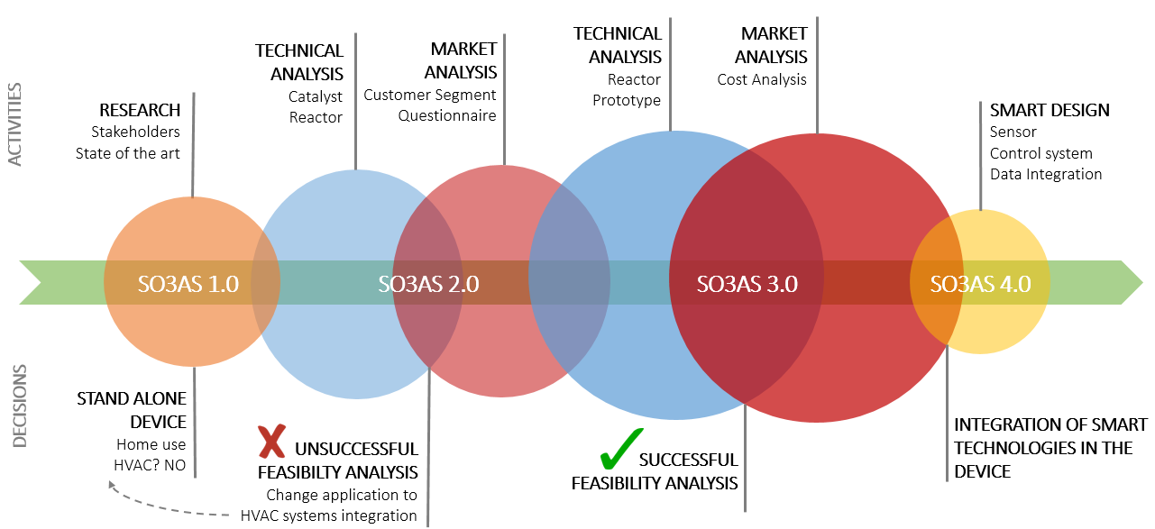

Opportunities’ exploration turned to a sequential refinement of the brief and solution.

**Generating a solution**

The designed ozone abatement system deal with low ozone concentration, which are caused by either industrial slips or pollution: the outlet concentration ranges have been selected according to environmental regulation standards. The abatement occurs at room temperature with Carulite®. Concerning the reactor design, the Team chose to rely on highly accurate computational fluid dynamics (CFD) simulations performed on MATLAB:

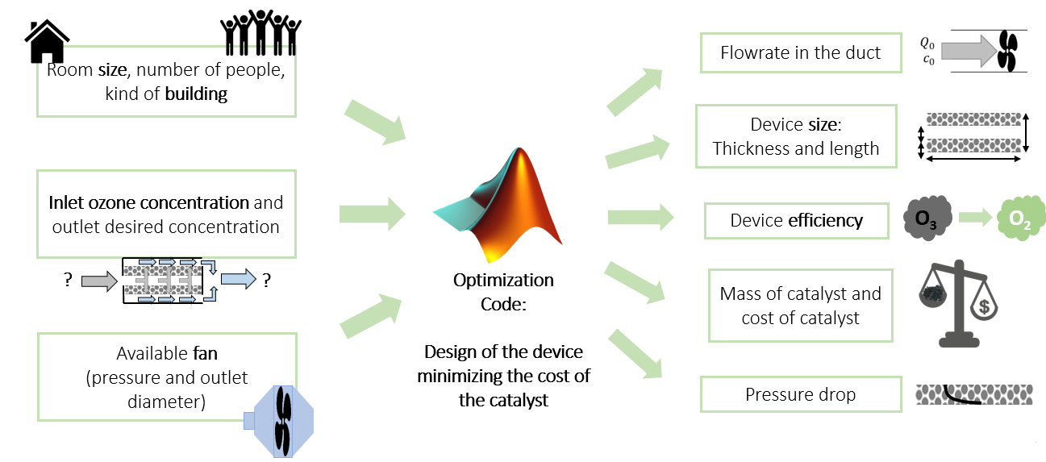

Solution conceptual architecture, with the input and output (optimized) data

Thanks to code flexibility, inlet/outlet concentrations required can be changed with no effort, thus resulting in an easily customizable design, by just tuning or setting such input values. This flexibility does not only regard the reactor itself, but also extends to the HVAC system integration: in fact, the code also performs the sizing of the HVAC duct based on the size of the building and number of people considered. The design proposed for the reactor was a radial reactor, as sketched in detail:

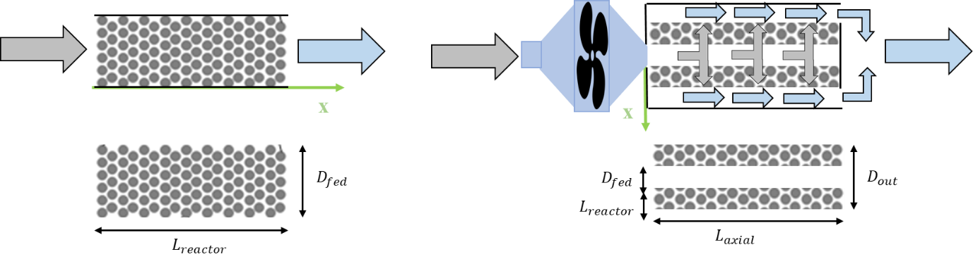

Radial Reactor architecture

The air flow redistributes on a large catalyst surface, achieving small pressure drops, which can be easily overcome by a low energy consumption axial fan, which is already available in HVAC systems. This innovative solution allows also minimizing the amount of catalyst used, and therefore the costs, for a feasible indoor ozone abatement. In addition, the device can be easily integrated with both existing or *new* HVAC ducts, in their design phase.   
In addition, a sensor measuring ozone concentration can be installed allowing constant monitoring of the actual inlet and outlet concentrations via a simple user interface. Further implementation of a control system for automatic on/off switching of the fan would even bring to energy savings. These additional features finally allow making the device smart and ready to break through in the context of industry 4.0, which exploits the cyber-physical system shown below:

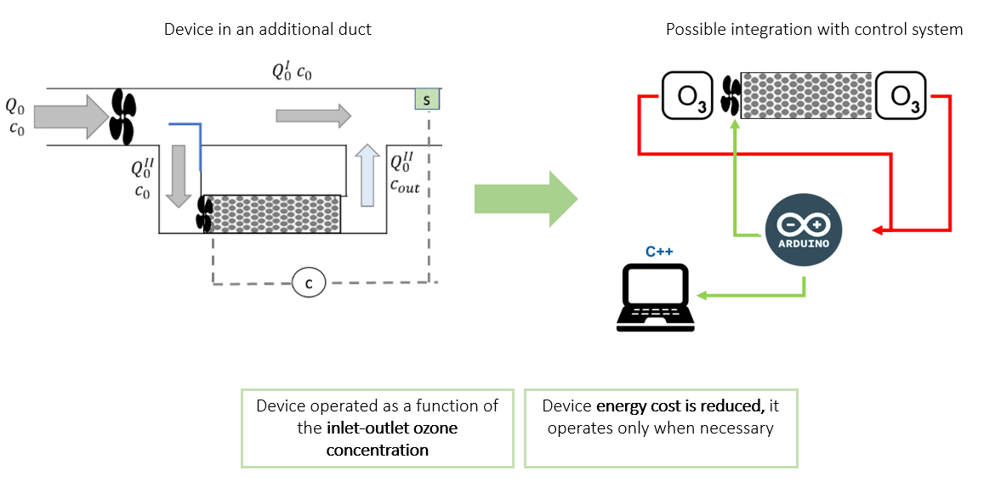

Solution practical architecture, which works on the given (optimized) data by the code

On the commercial side, even though in California there is an existing market, the team has chosen to focus its attention on northern Italy. In this region the solution proposed would emerge as the first indoor ozone abatement since no market currently exists. Here, the device would enter a market in which people awareness about ozone pollution is not high. Thus, the team performed a questionnaire in order to understand the citizens’ awareness about the ozone problem and to sensitize people about pollution. Finally, a full cost analysis accounting for both materials and manufacturing process has been performed. The final price is of the order of few thousands of euros, which is affordable for both public and private institutions such as schools, hospitals, and private companies.   
In conclusion, the team thinks that its device can spread thanks to an increase in pollution awareness through sensitization campaign. In fact, in this way it would be possible to force authority to set more stringent regulations about ozone pollution.

**Main bibliographic references**

T. Batakliev, V. Georgiev., M. Anachkov, S. Rakovsky and G. Zaikov, Ozone decomposition, *Interdisciplinary Toxicology*, 7:2, 47–59, 2014.

B. B. Daly, Woods practical guide to fan engineering, Woods of Colchester Limited, 1978.

M. Lippmann, HEALTH EFFECTS OF OZONE A Critical Review, *Journal of the Air Pollution Control Association*, 39:5, 672-695, 1989.

Mintz, Technical Assistance Document for the Reporting of Daily Air Quality – the Air Quality Index (AQI), *U.S. Environmental Protection Agency*, Triangle Park, North Carolina, 2012.

J. Pei, Y. Lua, and X. Yin. Catalytic Decomposition of Ozone by CuO/MnO2-Performance, Kinetics and Application Analysis. *Procedia Engineering*, 121, 792-800 , 2015.

[www.arpalombardia.it](http://www.arpalombardia.it)

[www.epa.gov/](http://www.epa.gov/)

[www.ozonesolutions.com](http://www.ozonesolutions.com)